TABLET PUNCHING MACHINE
Principle:-
The basic principle behind working the tablet punching machine is the hydraulic pressure. The pressure is been transmitted via static fluid to all direction in same proportion.
Diagram :-
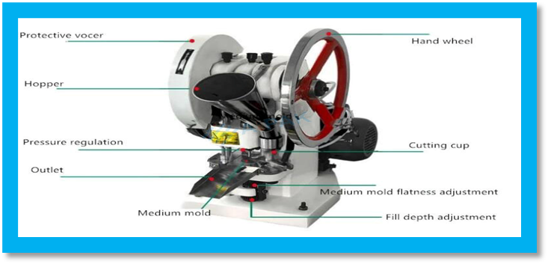
working:-
- Filling process:-
At this stage, the upper punch is withdrawn from the die using the upper cam. As the bottom punch is lowered, the powder in the hopper flows and thereby fills the die cavity. As the bottom punch moves upwards, any excess powder is swept away from the station.

- Compression process:-
At this stage, the upper cam forces the upper punch into the die cavity. A predetermined magnitude of force is then applied on the punches to compress powder into a desired tablet.

- Ejection process:-
In ejection process first upper cam withdraw the upper punch. At the same time, the lower punch moves upwards, expelling compressed tablets. In most machines, it is the surface plate that removes compressed tablets from system. This is continuous process and is monitored to ensure consistency and accuracy of the tablet compression process

Roll no :- 82 , 89 , 99

